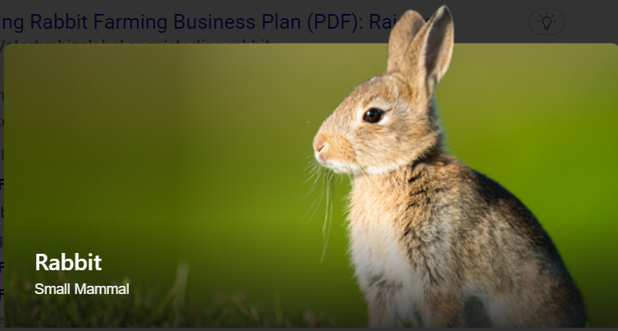

Rabbit farming is the process of breeding, fattening and reproducing rabbits, economically to obtain the maximum benefit in the sale of its products and by-products. Rabbit production is little exploited due to several reasons such as ignorance of the population about the nutritional value of the rabbit meat, eating patterns and little information about the species, etc.

**Terminology**

* Buck: A mature male rabbit used for breeding
* Doe: A mature female rabbit used for breeding
* Kit: A young rabbit whose eyes are not yet opened
* Bunny: A young rabbit below 20 weeks age
* Fryer: 10 to 12 weeks old rabbits ready for market
* Litter: Kits born in a single kindling
* Kindling: Act of parturition
* Weaner: A newly weaned rabbit
* Rabbitry: A place where domesticated rabbits are kept
* Caecotrophy/Coprophagy: The consumption of own fecal matter

**Advantages or Benefits of Rabbit Farming**

1. Rabbits need a little surface for their accommodation. The area desired for the raising of rabbits will depend on how many animals we want to raise.
2. Rabbits are animals that reproduce quickly. It is possible to obtain from 4 to 6 births per year. Females can start their reproductive life at 4 months of age, provided they have reached a weight of 3 kg; and males at 5-6 months of age. Gestation is 30 days, lactation 35 days, and slaughter when they reach a live weight of 2.4 kg.
3. The feeding of rabbits is simple. We can use products from the garden, forage, grains, some leaves of trees.
4. Animal care is accessible as they can be cared for by young people, women and the elderly. Rabbits adapt to wide temperature ranges. The adult animal tolerates cold well, newborn rabbits should be given proper protection. In the summer, you must have shade (deciduous trees) and protection with half shade cloth. Their cages can be built with different low-cost materials or old cages (chickens).
5. The waste of the rabbits, that is, their manure can be recycled through the Californian Red worm, to obtain excellent quality vermicompost (organic fertilizer).
6. Raising rabbits is an excellent way to improve the diet of our family. Rabbit meat is healthy because it is rich in protein and low in fat. Rabbit meat is considered a healthy food from a nutritional point of view: it is part of a healthy diet. It is a food indicated for all kinds of ages: children, teenagers, athletes, old people, overweight and obese people, people who do low-calorie diets, people with high blood pressure, and patients with hypercholesterolemia and hyperuricemia or gout.

**Breeds of Rabbits**

There are numerous breeds of rabbits, but we will only mention a few. Below are common breeds of rabbits:

1. **California breed**: It weighs between 3.6 – 5 kg. It has a white coat color with colored feet, nose, ears, and tail.
2. **New Zealand breed**: It weighs between 4.1 – 5.4 kg. It has white, black, or red coat color.
3. **American Chinchilla breed**: It weighs between 4.1 – 5.4 kg. Its surface fur is greyish, underfur deep-blue grey, and belly is white.
4. **Champagne D’argent breed**: It has a weight that ranges between 4.1 – 5.4 kg. The underfur is dark slate blue, while the surface fur is blue-white or silver.
5. [**Flemish Giant Breed**](https://www.livestocking.net/flemish-giant-rabbit): This breed weighs between 5.9 – 7.3kg. Its coat color is grey, sandy, white or blue.

Other breeds are:

* Angora
* Mini Lop rabbit
* English Lop
* Holland Lop
* Dwarf Dutch
* Lion head
* Beaver Rex
* Chinchilla Rex
* Rex Albino

## Rabbit Feeds and Feeding

The rabbit’s diet must be made up of three main elements: Hay, Fresh Feed, and Concentrate Feed. Of these, hay plays a fundamental role due to its contribution of fibre and must make up most of the diet of a healthy rabbit. Other elements, such as some seeds (nuts, cereals, legumes) should only be given in minimal quantities.

In general, we could divide the rabbit’s feeding as follows:

* 80% hay or fresh grass
* 15% fresh food (leafy vegetables or wild herbs)
* 5% concentrate feed

The feeds that you can give rabbits are:

Leafy vegetables: potato leaves, carrots, lettuces, cabbages. But only give lettuces and cabbages to adult rabbits alone.

* Hays: Well-cured green legumes hays such as cowpeas, groundnuts, soybeans, stylo, etc. are palatable and they make rabbits grow well.
* Starches and grains: potatoes (must be boiled) and grains such as millets, guinea corn, maize, rice, etc. can be added to the animal’s ration mixtures.

### Feeding of Baby Rabbits

During the first 3 weeks, the only feed for the baby rabbits is the doe’s milk. After 2-3 weeks, the baby rabbits will start to eat the grass and concentrates, as well as suckling the doe. As they get older, they will adjust themselves to live entirely on the feeds from outside. Till the baby rabbits remain on suckling, their mother (doe) must get enough good quality feed (concentrates, green roughages and clean water) to sustain lactation demand. A lactating doe while nursing 8 young, will consume concentrates more than 250 g/day, while the water consumption may be as high as 3-5 liters/day. All vegetable rations are generally supplemented with salt and a source of calcium, such as bone-meal. Rations must include a balanced concentrates mixture.

## Housing of Rabbits

Rabbits need to be housed to protect them and to prevent them from running away. There are several ways of housing rabbits depending largely on the type of rabbit farming, i.e., whether backyard or big commercial type, climate, and the availability of finance. Backyard rabbit keepers who usually cannot afford to spend much on materials for his rabbitry, get satisfied with locally available old boxes, offcuts, bamboo, tin cans, etc. The small commercial farmers, on the other hand, may be interested in using moderately costly wire cages. Most important features of housing are; rabbits must not only be protected from extremes of heat, sun and cold, wind, rain and predators, but also should feel comfortable which includes proper space, suitable temperature, dry condition of the cages, proper ventilation along with some equipment like feeders, hoppers and hay rack.

On commercial farms, rabbits are kept mostly in wire mesh cages. These can be arranged in a single tier, but to make better use of the space in a building, they may be stacked in two or even three tiers. The cages in the upper tiers are set back so that no cage is directly above another, to allow the urine and feces to fall into the pit below. The selected arrangement must permit the staff to handle and feed all the rabbits easily. The cages are made of galvanized wire mesh, and the joints must be smooth. An even floor surface is essential to avoid causing abrasions on the under surfaces of the hind feet. A square mesh not exceeding 19 x 19 mm is favored as this allows fecal pellets to pass through and does not cause foot injuries.

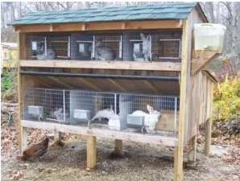

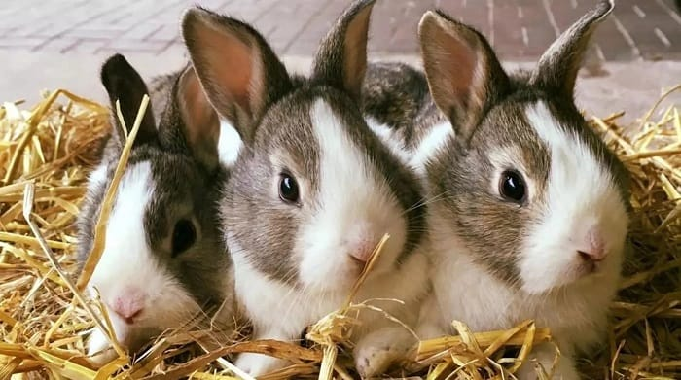

There are many rabbit breeds available throughout the world.

## Common Diseases of Rabbits

1. Internal parasites such as worm infestation, coccidial infection, etc. Deworm animals regularly and avoid giving animals moldy feeds. Also, administer coccidiostat at an early age or anti-coccidial drugs.
2. External parasites such as mites and lice infestation. Clean the hutches regularly.
3. Bacterial infections such as Salmonellosis, Escherichia coli (E. coli), etc.
4. Viral infections such as Myxomatosis (Big head disease), Rabbit Calicivirus disease (Viral hemorrhagic disease).